Total Marks:
Obtained Marks:

DIGITAL LOGICS DESIGN

(DOCUMENT)

Digital Voting Machine Using Arduino

Submitted to: Sir Muhammad Farooq

Name | Registration number
Raja Mubashir | 2512349
Noor Muhammad Ahsan | 2512341
Ibrahim Saqib Khan | 2512331

Table of Contents
ABSTRACT 2
INTRODUCTION 3
1.1 OBJECTIVE 3
1.2. COMPONENTS LIST 3
1.3 METHODOLOGY 4
1.4. WORKING PRINCIPLE 6
1.5. TRUTH TABLE 6
1.5.2 Counter States (74LS192) 7

Table of Figure

Figure 1 5
Figure 2 5
Figure 3 6

ABSTRACT
- This project presents a simple Digital Voting Machine using TTL logic ICs and Arduino-based concepts. The system takes vote inputs through switches and processes them using logic gates.
- A valid vote signal is sent to the 74LS192 counter which increases the vote count. The count is then displayed on a 7-segment display using the 74LS47 decoder.
- Although the project idea is Arduino-based, TTL ICs were used in Multisim for practical implementation. The project demonstrates vote counting, logic processing, and real-time display operation

INTRODUCTION
A Digital Voting Machine (DVM) is an electronic system used to record and display votes digitally. This project is based on the concept of an Arduino voting system, but the practical simulation is implemented using TTL logic ICs in NI Multisim because Arduino simulation was not available.
The project uses logic gates, a BCD counter, and a 7-segment display to count and display votes. It helps in understanding both Digital Logic Design and basic embedded system concepts.
.

OBJECTIVE
- To design a Digital Voting Machine.
- To implement voting logic using TTL ICs.
- To count votes using the 74LS192 counter.
- To display vote count on a 7-segment display.
- To understand combinational and sequential logic circuits.
- To compare Arduino-based and IC-based implementations.

1.2. COMPONENTS LIST
Component | Quantity | Description
74LS192D | 1 | BCD Counter
74LS47N | 1 | BCD-to-7-segment decoder
7-Segment Display | 1 | Displays vote count
AND Gates | 3 | Logic Processing
OR Gates | 3 | Logic Processing
Push Buttons | 3 | Voting Inputs
Reset Switch | 1 | Clears count
LED | 1 | Indicates valid output
5V DC Supply | 1 | Circuit power supply
Resistors | 7 | Current Limiting
Connecting Wires | As required | Circuit Connections

1.3 METHODOLOGY
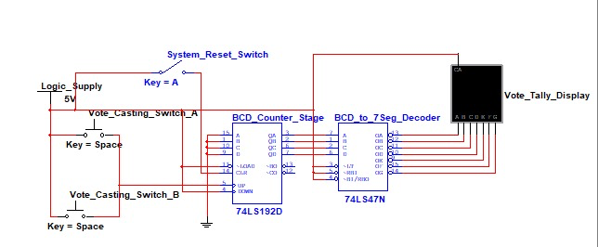
Figure 1

OFF Circuit

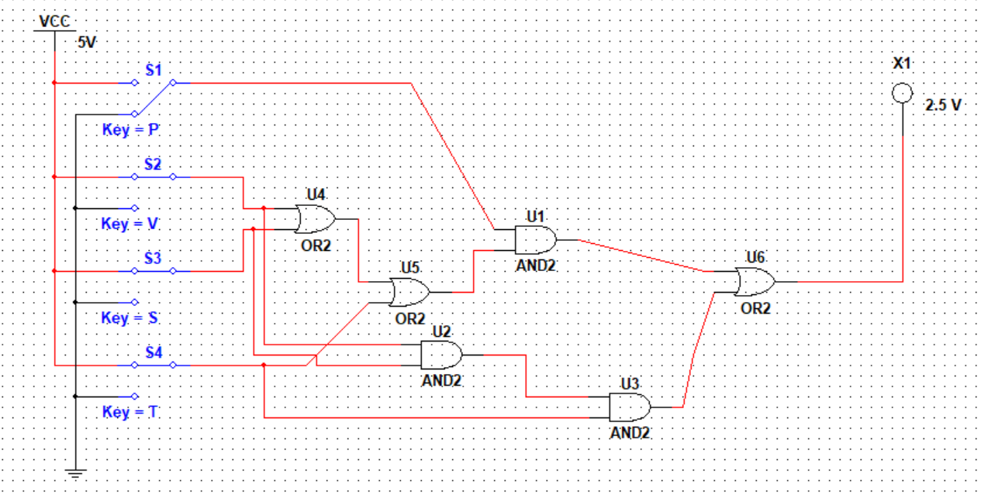
Figure 2

ON Circuit

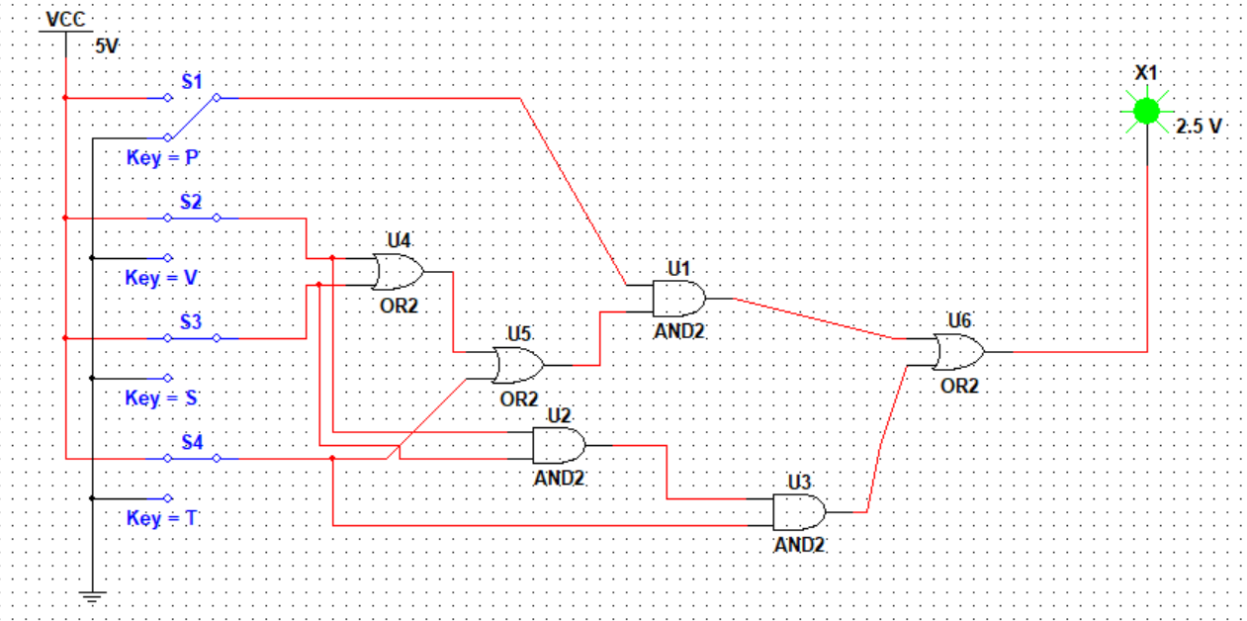
Figure 3
ON Circuit

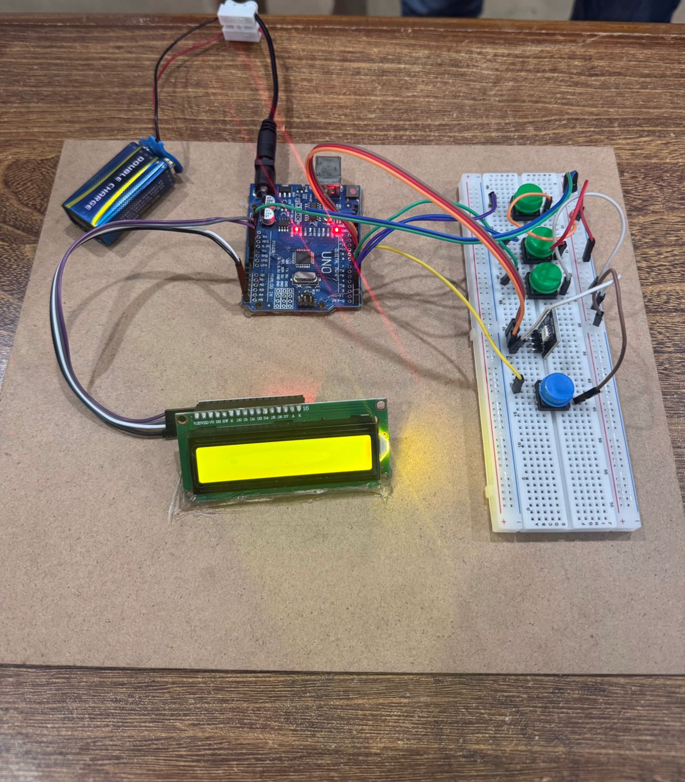

The project contains two main circuits:

Vote Validation Circuit: This circuit uses AND and OR gates to check valid voting conditions. When the correct input condition is achieved, the LED turns ON and a valid signal is generated.

Vote Counting Circuit: This circuit uses:
- 74LS192 counter
- 74LS47 decoder
- 7-segment display
The counter increases the vote count and the display shows the updated tally.

Arduino vs IC-Based System: In Arduino systems, counting is done through programming. While in IC-based systems, counting is done directly through hardware logic circuits.
Both systems perform similar functions but use different methods.

1.4. WORKING PRINCIPLE
- Power Supply: The circuit operates using a 5V DC supply. Initially, the reset switch sets the display to zero.
- Vote Input: The push-button switches provide voting inputs to the logic gate circuit.
- Vote Validation: AND and OR gates verify valid input conditions. If the condition is correct, the LED turns ON and a pulse is sent to the counter.
- Vote Counting: The 74LS192 counter receives the pulse and increases the count by one.
- Display Operation: The BCD output from the counter is sent to the 74LS47 decoder which converts it into signals for the 7-segment display. The display shows the current vote count.
- Reset Function: Pressing the reset switch clears the counter and resets the display to zero.

1.5. TRUTH TABLE

1.5.1 Vote Input Logic

Input Condition | OUTPUT | LED | Counter
Invalid Input | LOW | OFF | No Change
Valid Input | HIGH | ON | Count +1

1.5.2 Counter States (74LS192)

Vote Pulse | BCD Output | Decimal Value
0 | 0 0 0 0 | 0
1 | 0 0 0 1 | 1
2 | 0 0 1 0 | 2
3 | 0 0 1 1 | 3
4 | 0 1 0 0 | 4
5 | 0 1 0 1 | 5
6 | 0 1 1 0 | 6
7 | 0 1 1 1 | 7
8 | 1 0 0 0 | 8
9 | 1 0 0 1 | 9

1.5.3 BCD to 7-Segment Truth Table (Active LOW – 74LS47N)

BCD (D C B A) | a | b | c | d | e | f | g | Display
0 0 0 0 | 0 | 0 | 0 | 0 | 0 | 0 | 1 | 0
0 0 0 1 | 1 | 0 | 0 | 1 | 1 | 1 | 1 | 1
0 0 1 0 | 0 | 0 | 1 | 0 | 0 | 1 | 0 | 2
0 0 1 1 | 0 | 0 | 0 | 0 | 1 | 1 | 0 | 3
0 1 0 0 | 1 | 0 | 0 | 1 | 1 | 0 | 0 | 4
0 1 0 1 | 0 | 1 | 0 | 0 | 1 | 0 | 0 | 5
0 1 1 0 | 0 | 1 | 0 | 0 | 0 | 0 | 0 | 6
0 1 1 1 | 0 | 0 | 0 | 1 | 1 | 1 | 1 | 7
1 0 0 0 | 0 | 0 | 0 | 0 | 0 | 0 | 0 | 8
1 0 0 1 | 0 | 0 | 0 | 0 | 1 | 0 | 0 | 9

Conclusion
The Digital Voting Machine successfully demonstrates vote validation, vote counting, and real-time display using TTL logic ICs. The project combines logic gates, counters, and decoders to simulate an electronic voting system.

Although the original concept was Arduino-based, TTL ICs were used for simulation in Multisim. The project helps in understanding both hardware logic circuits and Arduino-based system concepts.

References
- Standard Arduino UNO System: A foundational guide for creating an EVM using an Arduino UNO, push buttons for candidate selection, and a 16x2 LCD to display results. This design is ideal for understanding basic vote-counting logic and hardware interfacing.
- Biometric Authenticated System: A research paper titled "Arduino-Based Authenticated Voting Machine (AVM) using RFID and Fingerprint" explores advanced security layers. It details the use of an Arduino Mega to integrate RFID cards and fingerprint scanners for multi-factor voter verification.
- IoT and Cloud-Integrated System: This reference discusses a Secure Electronic Voting System with IoT and PubNub, which allows for real-time online result monitoring and remote data storage to enhance transparency.

